**Virtual University of Pakistan** SEMESTER Spring 2024

CS614 – Data Warehousing

Assignment No.2 (Graded)

## Maximum Marks: 20

**Instructions *Due Date: 24 June 2024***

The purpose of this assignment is to give you hands-on practice. It is expected that students will solve the assignment themselves. The following rules will apply during the evaluation of the assignment.

* Cheating from any source will result in zero marks in the assignment.
* The submitted assignment does NOT open or the file is corrupted.
* No assignment after the due date will be accepted.
* Students can submit HTML, Images and Plain text only in this inline Mode. The table can also be drawn in the interface.
* DOC/pdf File uploading option will not be available in inline assignment submission.

**Uploading Assignment Instruction**

Follow the given instructions to submit the inline assignments.

* Images of the following formats can be inserted in the inline assignment interface.

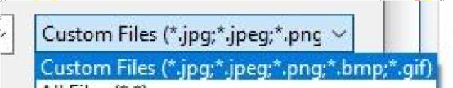

* Images and tables can be inserted using the following highlighted options in the interface.

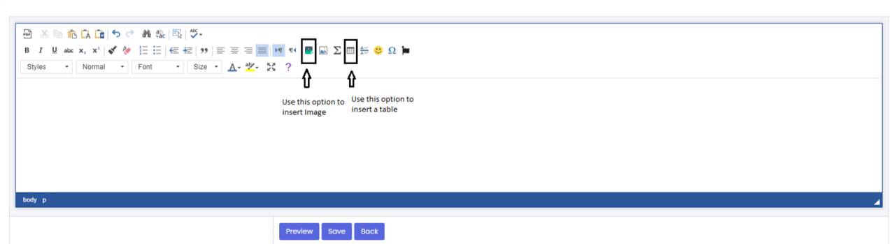

**Virtual University of Pakistan** SEMESTER Spring 2024

# Objective & Learning Outcome

The objective of this assignment is to give:

* The concept of Data Parallelism, Pipelining: Input vs. Speed-Up
* The concept of indexing techniques on databases such as Bitmap Indexing.

# Question No. 1 (10 Marks)

Consider a factory that processes widgets through a series of stages: cutting, assembling, and painting. This can be represented as a three-stage pipeline. The time to process one widget through these stages sequentially is T.

**Given:**

Number of stages in the pipeline, M = 3 (cutting, assembling, painting)

Sequential execution time for one widget = T,

The ideal time for pipelined execution of one widget = T

Time for sequential execution of N tasks = N.T

You will calculate the speed-up for **15 and 30 widgets** using the following pipelining: speed-up calculation.

$$Speed-up \left(S\right)= \frac{NT}{T+\left(N-1\right)×\frac{T}{M}}$$

1. Speed-up(S) for 15 Widgets =?
2. Speed-up(S) for 30 Widgets =?

# Question No. 2 (10 Marks)

Consider the table given below. Create an index table for columns “Year of Admission” in the context of the bitmap index.

|  |  |  |  |  |  |
| --- | --- | --- | --- | --- | --- |
| **Student_ID** | **Name** | **Gender** | **City** | **Department** | **Year of Admission** |
| STD101 | ALI KHAN | M | Lahore | Computer Science | 2021 |
| STD102 | SAIMA RAUF | F | Karachi | Business Administration | 2020 |
| STD103 | UMAIR ZAHID | M | Lahore | Computer Science | 2022 |
| STD104 | FATIMA ALI | F | Lahore | Mathematics | 2021 |
| STD105 | AHMED RAZA | M | Karachi | Business Administration | 2020 |

## Submission Guidelines:

The assignment will be submitted as an inline assignment.

## This assignment will cover the concepts discussed in lectures 24-27.

**Note: Plagiarism will be checked for each question. Please answer the questions in your own words and marks will be awarded based on your answer and plagiarism report.**

For any query about the assignment, contact at email [CS614@vu.edu.pk](mailto:CS614@vu.edu.pk)